**Programming Project - Coin Count**

A local youth club has organised several coin collections for a charity during the year. People have been very generous and a lot of money has been collected. The coins now need to be counted and paid into the charity’s bank account.

Six club members have volunteered to count the coins. The bank has supplied plastic bags for the coins. The coins must be bagged in set amounts as shown.

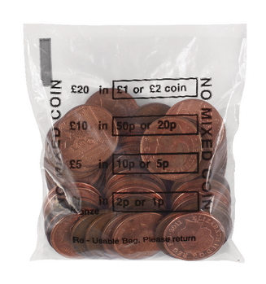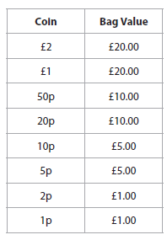

Each bag must hold exactly the value of coins shown in the table and contain only one type of coin. The volunteers sort the coins by type before counting and bagging them. The club leader wants to check that the coins have been counted correctly by weighing each bag. At this stage, any bag containing the wrong number of coins is corrected. This checking process will take place over several sessions.

The weight of each coin, in grams (g), is shown in the table.

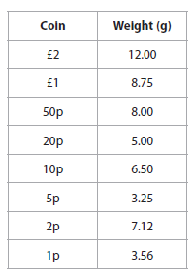

The youth club leader wants a computer program to check the coin count. The program

must:

~~• allow the user to input the volunteer’s name, type of coin and weight of bag~~

~~• validate the coin type~~

~~• indicate the number of coins to be added or removed to correct an inaccurate bag~~

~~weight~~

• maintain running totals of the number of bags checked and total value

• provide an option to display the total number of bags checked and total value

• monitor the accuracy of the volunteers counting the coins

• provide an option to display a list of the volunteers, sorted by accuracy, showing:

• the total number of bags they have counted

• the number of bags they counted correctly, as a percentage of their total.

• Save the data in a text file called CoinCount.txt

• Load CoinCount.txt at the beginning of each session.

• Update CoinCount.txt at the end of each session.

*Your task is to analyse this problem and to design, write (implement), test and refine a programmed solution. You must create test data to check that your program works as intended. Some sample test data is shown in the table.*

